**Advanced SQL Exercise**

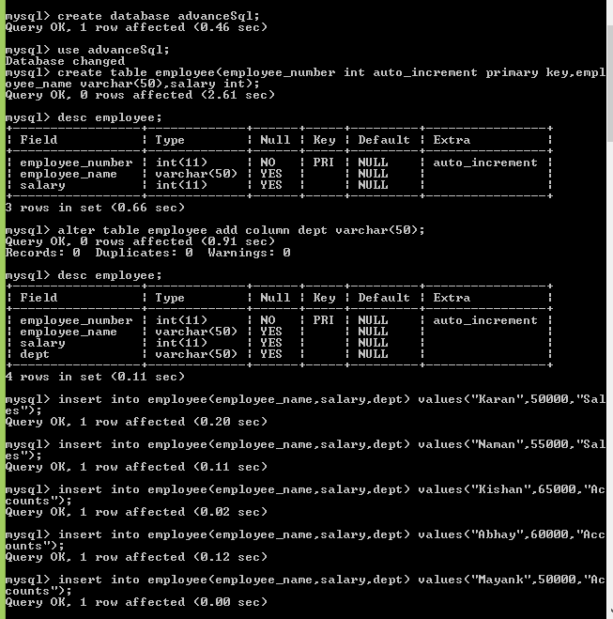

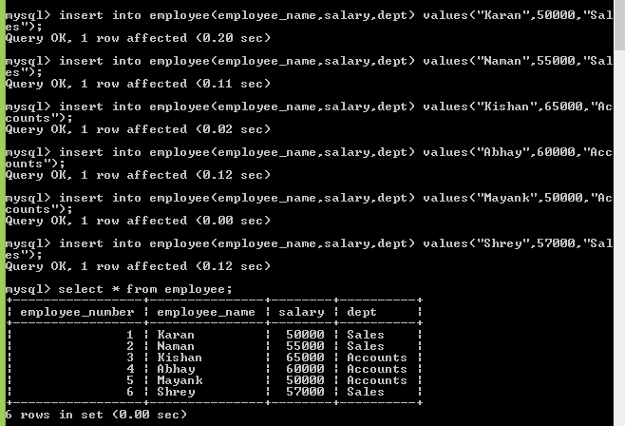

1. **Find all employees whose Employee name ends with 'N'.**

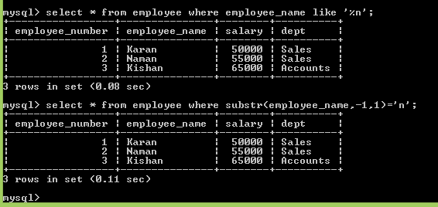

**List the employee number, the Employee name, and the last character of the Employee name.**

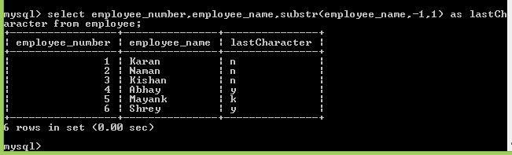

1. **write a procedure to increment the salary of employee who works in sales department**

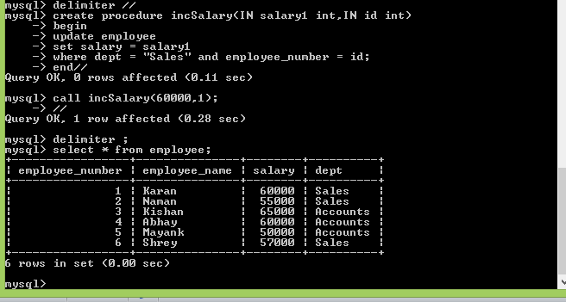

1. **write a function to find the total salary of employees, who works in Accounts department**

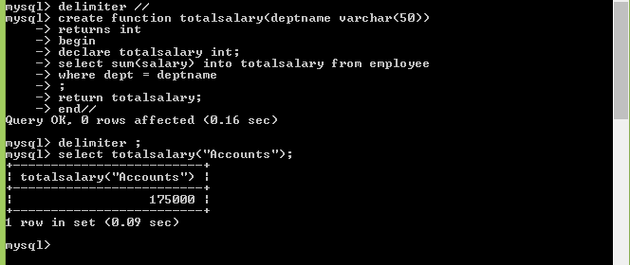

**4) create a new  table for keeping transaction records,record will be updated in this table when there is deduction in the salary,when salary is deducted a trigger is executed which insert employee name ,updatedby ,changedsalary,updateddate in new table.**





